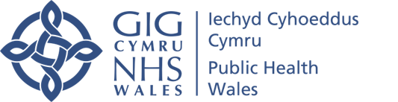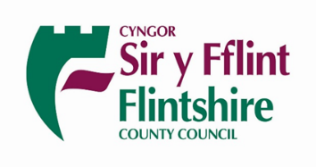
Ebost/Email: BCU.TTPRegionalHub@wales.nhs.uk
Ffôn/Tel: 03000 859992
Date: 27th November

Dear Parent or Carer,

Re: Contact of confirmed case of COVID-19 in St. Richard Gwyn Catholic High School

NHS Wales Test, Trace, Protect trace everyone who have been in contact with a person who has tested positive for COVID-19 (Coronavirus). Please note that this letter confirms that your child’s details have been registered with NHS Wales Test, Trace & Protect Team. You are now required to following the guidelines below.

Your child has been identified as a contact of a confirmed case of COVID-19 and will now need to self isolate with immediate effect. By identifying contacts and asking them to self-isolate, we will reduce the possible spread of COVID-19 from those contacts to their family, friends and the wider community.
Self-isolation advice requires your child to stay at home, not to go outdoors to exercise, to visit shops, family or friends, or to other public spaces. Please do not invite people to your house. Further information on self-isolation can be found in the link at the bottom of this letter.

If your child remains well then the other members of the household do not need to isolate and can continue with their normal activities. If your child is still well at the end of the period of self-isolation, they can return to St. Richard Gwyn Catholic High School and their other usual activities on the 10th December unless you are informed otherwise. The last day of isolation is 14 days after the last exposure with the positive case.
To reduce the risk of COVID-19 spreading, there are things that everyone in your family can do to help. These include:
- washing hands with soap and water often – do this for at least 20 seconds
- using hand sanitiser gel if soap and water are not available
- washing hands as soon as they get home
- covering their mouth and nose with a tissue or sleeve (not their hands) when they cough or sneeze
- putting used tissues in the bin immediately and washing hands afterwards

Please be alert for symptoms of COVID-19 in your child, which are:
- A new or continuous cough
- A high temperature
- A loss of or change to sense of smell or taste

If your child develops any of these symptoms, even if they are mild:
- Inform the Test, Trace and Protect (TTP) team by emailing ttp@flintshire.gov.uk and including your child’s name, address, DOB. School and location.
- If advised by TTP book a test by phoning 119 or through the online portal: https://www.nhs.uk/ask-for-a-coronavirus-test
- Inform St. Richard Gwyn Catholic High School that they are unwell with COVID-19 symptoms and that you have requested a test
- Your child should remain in self-isolation
- All other household members should isolate for 14 days from when your child developed symptoms
- Do not visit a GP surgery, pharmacy or hospital but if you require medical advice please contact NHS 111 or telephone your GP; if there is a medical emergency phone 999
- If you require medical advice for COVID-19 symptoms or another reason, please inform the healthcare worker that your child is a contact of a case of COVID-19 and in self-isolation
- Please follow the advice provided when your child receives their test result

Further formation on Test, Trace, Protect can be found here https://gov.wales/test-trace-protect-coronavirus
Further information on symptoms and self-isolation can be found here https://gov.wales/symptoms-and-self-isolation-contact-tracing
For general information on COVID-19 https://gov.wales/protect-yourself-others-coronavirus
The COVID-19 online symptom checker can tell you if you need medical help and advise you what to do https://gov.wales/check-if-you-need-coronavirus-medical-help

With best wishes
Catherine McCormack

Issued under the instruction of:
Position:
On behalf of Public Health Wales Health Protection Team

